How to disassembling and assembling bearings

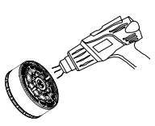
Step 1

Use a hot air gun to preheat the screws on the motor mounting
side at around 70 ℃ -80 ℃ (have dipped with a little screw glue when leaving the factory). As shown in the figure

Step 2
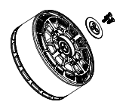
Use an Allen wrench to remove three M3 Allen countersunk head screws from the motor mounting side, remove the lock shaft gasket, then use a snap ring pliers to remove the snap ring, and finally remove the retaining ring. As shown in the figure

Step 3
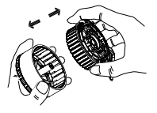
Grasp the stator component and rotor component of the motor with both hands separately, and pull outward with force to separate the motor rotor component from the stator component; Pay attention to balancing the force during the external pulling process, as the magnetic steel of the motor and the stator core have strong suction, so be careful your hands during the external pulling process. As shown in the figure

Step 4

Disassembly method of end cover bearing

Method 1:
Hold the motor stator component level with both hands, with the bearing end face facing upwards. Another person insert the small end of the bearing disassembly and assembly top rod into the bearing hole and tilt it about 10 degrees to support one edge of the bearing against the mounting side. Grasp the top rod with your hand and gently tap the bearing disassembly and assembly top rod with a rubber hammer. Then switch to the other side and strike it again, balancing the two sides. This cycle of action ensures that the bearing smoothly falls out of the bearing hole. As shown in the figure.
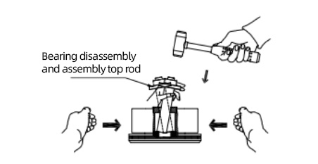

Method 2:
Hold the opposite side upwards level with both hands of the remove the stator assembly of one end of the bearing, and end side of the bearing is upwards.Another person places the small end of the top rod vertically on the bearing end face. Grasp the top rod with your hand and gently tap the bearing disassembly and assembly top rod with a rubber hammer. Then switch to the other side and strike it again, balancing the two sides. This cycle of action ensures that the bearing smoothly falls out of the bearing hole. As shown in the figure.

